**USE CASE DIAGRAM**

A use case diagram in the Unified Modeling Language (UML) is a type of behavioral diagram defined by and created from a Use-case analysis. Its purpose is to present a graphical overview of the functionality provided by a system in terms of actors, their goals (represented as use cases), and any dependencies between those use cases. The main purpose of a use case diagram is to show what system functions are performed for which actor. Roles of the actors in the system can be depicted.

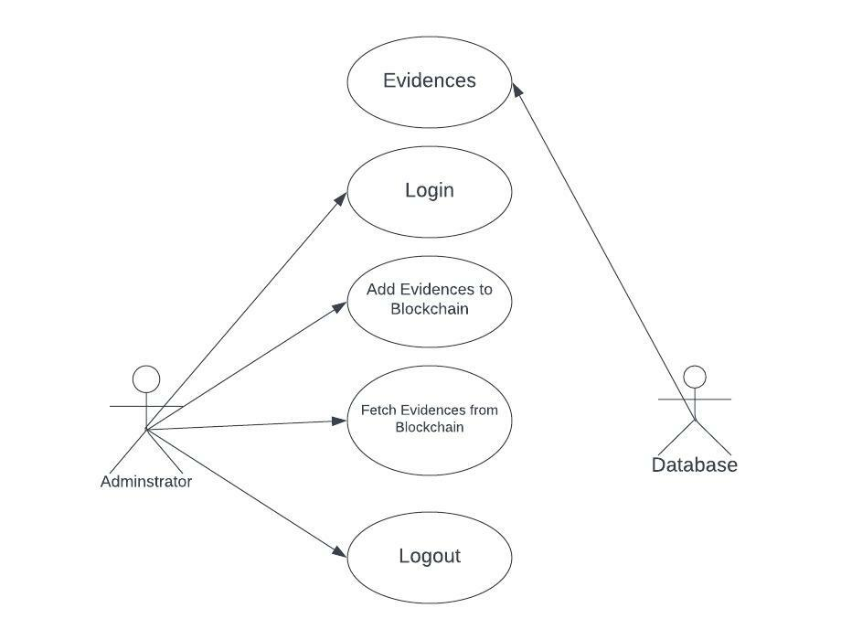

**CLASS DIAGRAM**

The class diagram is used to refine the use case diagram and define a detailed design of the system. The class diagram classifies the actors defined in the use case diagram into a set of interrelated classes. The relationship or association between the classes can be either an "is-a" or "has-a" relationship. Each class in the class diagram may be capable of providing certain functionalities. These functionalities provided by the class are termed "methods" of the class. Apart from this, each class may have certain "attributes" that uniquely identify the class.

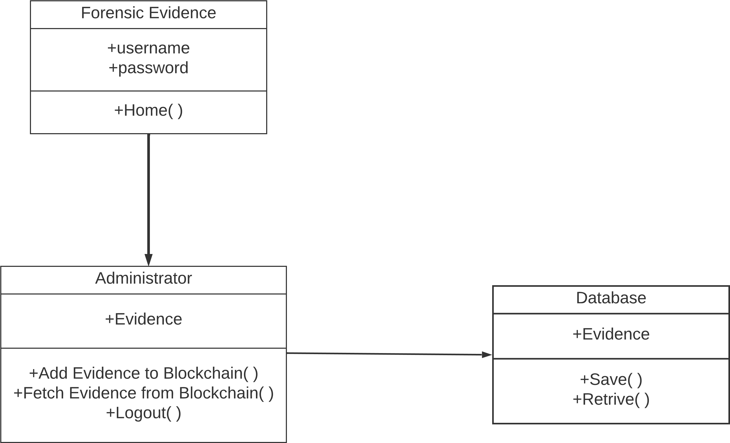

**SEQUENCE DIAGRAM**

A sequence diagram represents the interaction between different objects in the system. The important aspect of a sequence diagram is that it is time-ordered. This means that the exact sequence of the interactions between the objects is represented step by step. Different objects in the sequence diagram interact with each other by passing "messages".

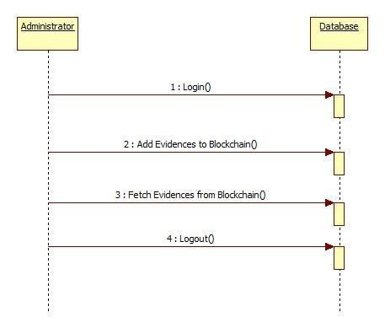

**ACTIVITY DIAGRAM**

The process flows in the system are captured in the activity diagram. Similar to a state diagram, an activity diagram also consists of activities, actions, transitions, initial and final states, and guard conditions.

